# Summary of Changes

To better support the migration of WIN data to the QUEST system, we have added the ability to export a selected year range of data for the below files. This will enable states to provide older years of data earlier and just the remaining years closer to the transition date, helping to spread out the work associated with converting to QUEST. This new process will also limit the files to those needed for the migration rather than including all of the files from the regular database dump.

1. Admin
2. Admin Lock
3. Control File
4. County
5. CtyTwn
6. CtyZone
7. Genrl Adm
8. LMA
9. Lock Table
10. MacMSA
11. MacNAICS
12. MSA
13. Quarterly
14. State Info
15. Wage Rec
16. WIA
17. WR-PredSucc

To run this utility, do the following:

1. Make sure that you have a ‘dumpdata’ folder under your ‘win202’ folder **and that it is EMPTY (make sure there are no files in the folder).**
2. Choose the “QUEST Migrate” tab on the maintenance tab:

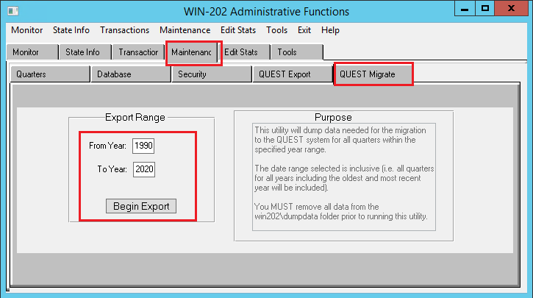

The “From Year” value will default to 1990 and the “To Year” value will default to the most recent year in your database.

1. Enter the range of years to be exported and click the “Begin Export” button. Note that ALL quarters for the range of years chosen will be exported:

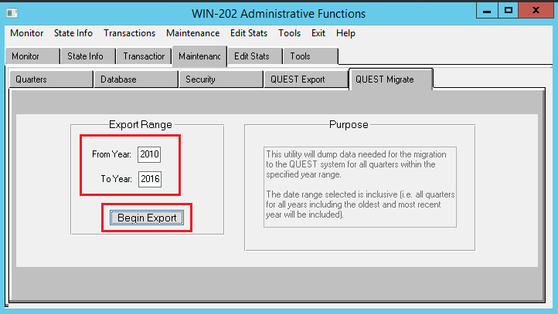

In the example above, all data for all quarters in the years of 2010 through 2016 will be

exported (i.e., 2010/1 through 2016/4).

1. All data (17 files) will be dumped into the win202\dumpdata folder:

